The following is the procedure to convert the TDM outputs to LUM inputs and run the LUM:

1. Convert the following skims to csv’s. This can be done using TransCAD by opening up the matrix and selecting Matrix→Export and exporting the rows in the matrix as a csv. Be sure to select the correct core:
   * HSKIMS_AM.mtx (AM_TIME) – HW.csv
   * wlb_AM_ttskim.mtx (Total Time) – LocalBus
   * wpm1_AM_ttskim.mtx (Total Time) - BRT
2. Add headers to the three skims using AddSkimHeader.exe.
3. Run the script {I:\000JFLOOD\Cube Land\Land Use Scripts\}CombineTransit.py to combine the two transit skims into a general transit skim that uses the minimum of the two travel times between each skim. Before running the script, edit it so it points to the correct file locations.
4. Using the CILUM user interface, create a new scenario. The base scenario should be the same as the base scenarios for the other iterations of the integrated model.
5. Copy the MODEL\Inputs folder from another iteration of the model into the MODEL folder in the current scenario.
6. Calculate the accessibilities and attractivenesses using the Accessibility ArcGIS tools found in IndyGeoTools. Use the highway and transit skims that were created before, and the file FILES\TAZ_OUT.shp within the scenario directory for the TAZ file.

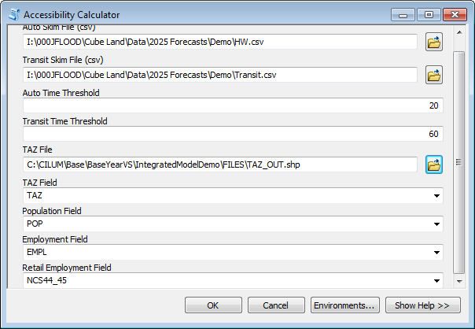

1. Update the accessibility using the UpdateAccessibility.py script. Edit it before running it to make sure it points to the correct files.
2. Set the endogenous variables using the SetEndogVar.py script. Edit it before running it to make sure it points to the correct files.
3. Run the model. Select the scenario in the CILUM user interface, and then click “Run Model.”
4. Run the script AverageDBF.py. Make sure the first file points to the previous iteration’s TAZ_OUT.dbf file and that the second one points to the current iteration’s TAZ_OUT.dbf file. Also, be sure to indicate the correct iteration number, as that affects the weights.
5. Change the file FILES\{Scenario}Summary.xslx to FILES\{Scenario}Summary_RAW.xslx, FILES\TAZ_OUT.dbf to FILES\ TAZ_OUT _RAW.dbf, FILES\ TAZ_OUT _AVERAGED.dbf to FILES\ TAZ_OUT.dbf.
6. Using the CILUM interface, run post-processing for the scenario. Check “Write Summary.”